# **Installing Jenkins**

* The procedures in this document are for new

installation of Jenkins.

**Pre-requisites:**

1. Install JDK
2. Set environment variable for JDK
3. Download and Install Jenkins
4. Run Jenkins on localhost 8080
5. Jenkins server interface
6. Build and run a job on Jenkins

**1. Install JDK:**

* To download and install JDK, Go to following link.

https[://w](http://www.oracle.com/in/java/technologies/javase/javase8-archive-downloads.html)ww.[oracle.com/in/java/technologies/javase/javase8-archive-downloads.html](http://www.oracle.com/in/java/technologies/javase/javase8-archive-downloads.html)

* Click on windows x64 download

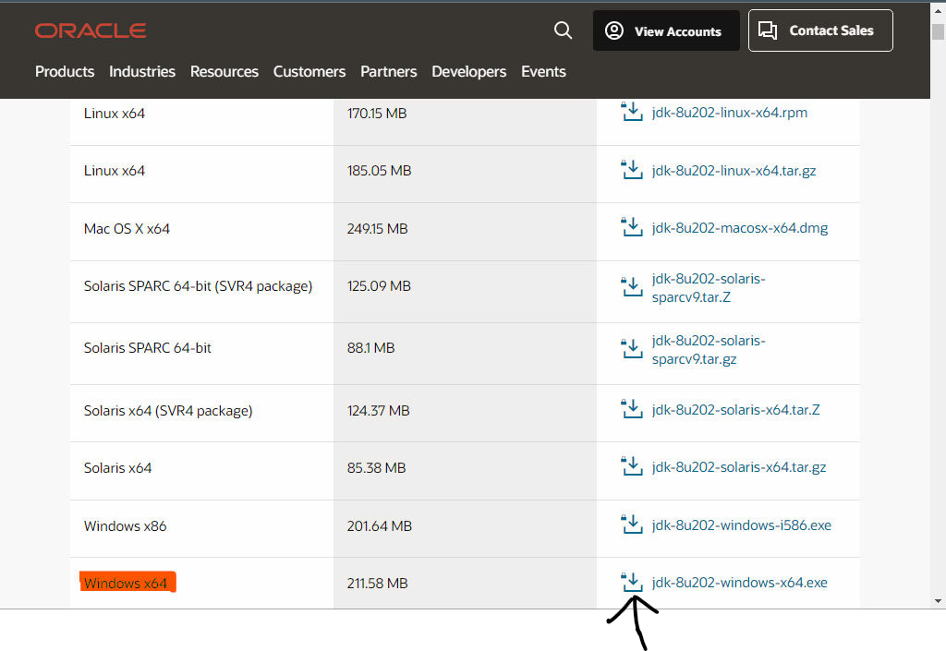

* When you click on the Installation link the popup will be open. Click on “I reviewed and accept the Oracle Technology Network License Agreement for Oracle Java SE” development kit and you will be redirected to the login page. If you don’t have an oracle account you can easily sign up by adding basics details of yours.

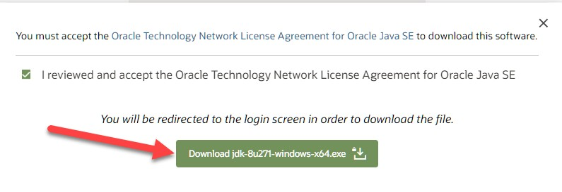

**NOTE:** You will be required to create an Oracle Account to start Java 8 download of the file.

* Once the Java JDK 8 download is complete, run the exe for install JDK. Click Next

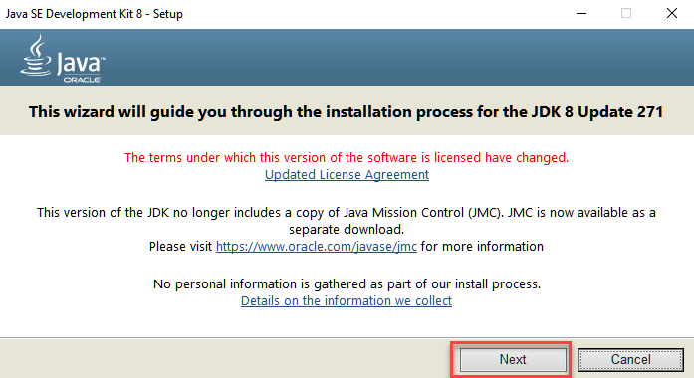

* Select the PATH to install Java in Windows… You can leave it Default.

Click next.

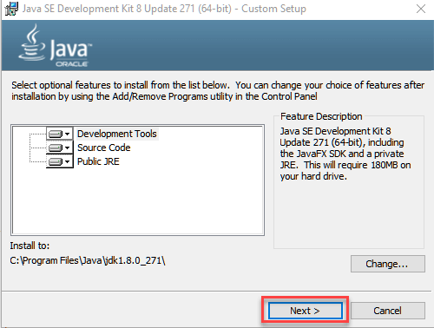

**NOTE:** Follow the onscreen instructions in succeeding steps to install Java

8 on Windows 10.

* Once you install Java in windows, click close.

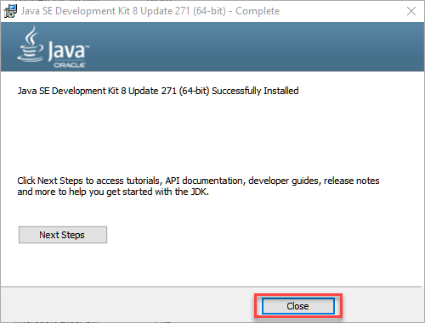

* After you install java, Open the c drive->program files->Java
* Under java folder, you can see 2 folders jdk & jre

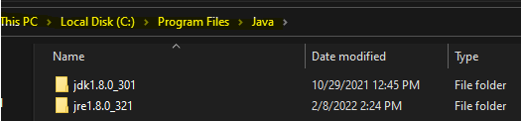

**2. How to set Environment Variables in Java: Path and Classpath**

**Step 1)** Right Click on the My Computer and Select the properties

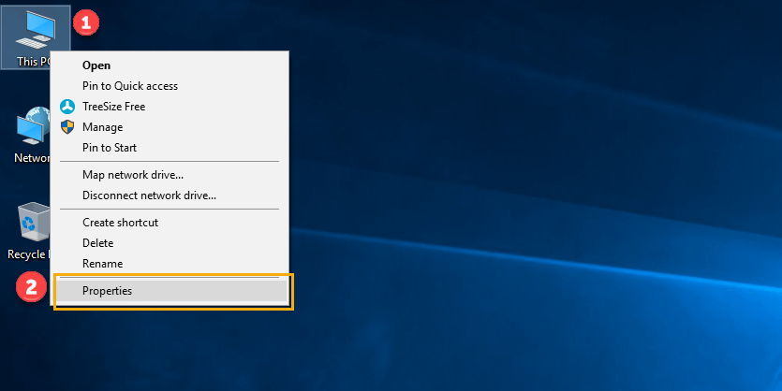

* **Step 2)** Click on advanced system settings

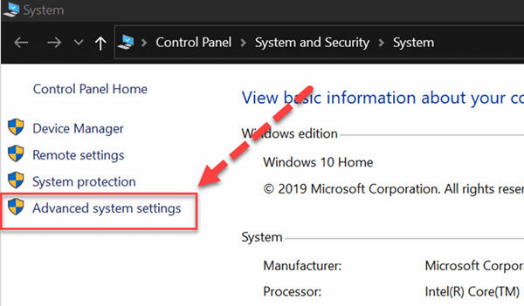

* **Step 3)** Click on Environment Variables to set Java runtime environment

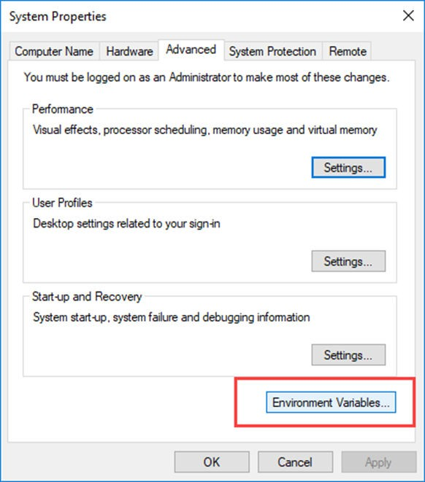

* **Step 4)** Click on new Button of User variables

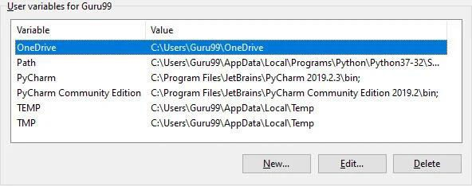

**Step 5)** Type PATH in the Variable name.

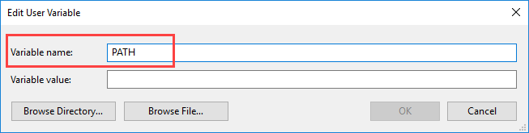

**Step 6)** Copy the path of bin folder which is

installed in JDK folder.

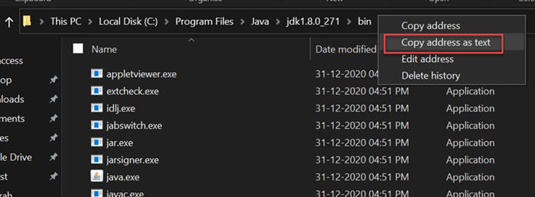

**Step 7)** Paste Path of bin folder in Variable value. Click on OK Button.

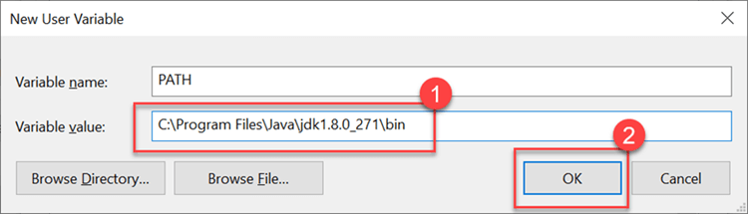

**Step 8)** You can follow a similar process to set CLASSPATH.

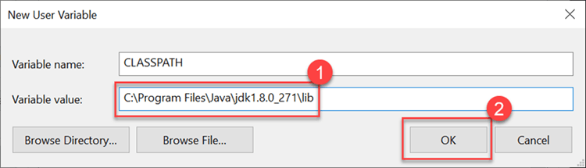

**Step 9)** Click on OK button

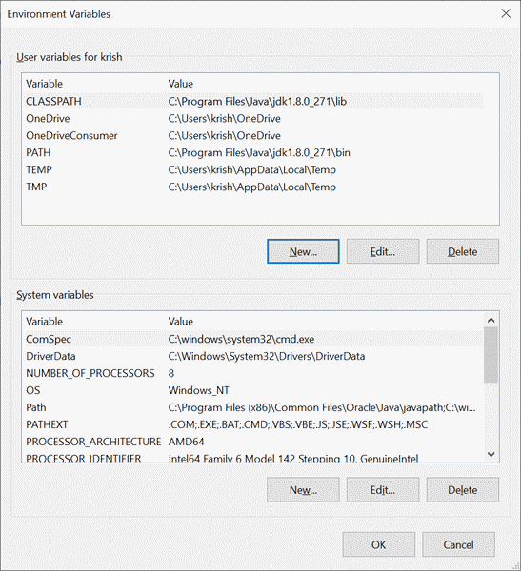

**Step 10)** Go to command prompt and type

## java -version command.

* If you see a screen like below, Java is installed.

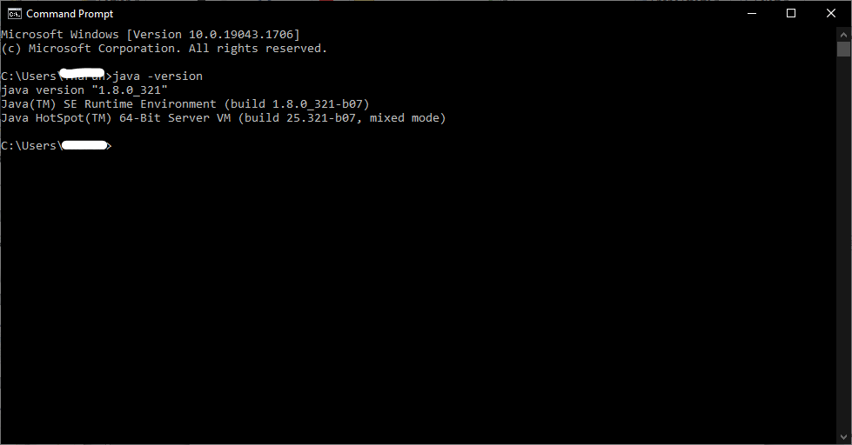

**3. Download and Install Jenkins**

* To download Jenkins go to the follow link https://[www.jenkins.io/download/](http://www.jenkins.io/download/)
* Under LTS, click on windows.

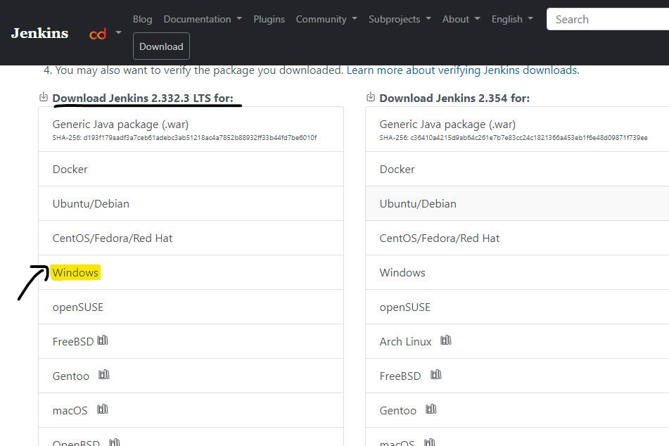

* After the file is downloaded, unzip it.

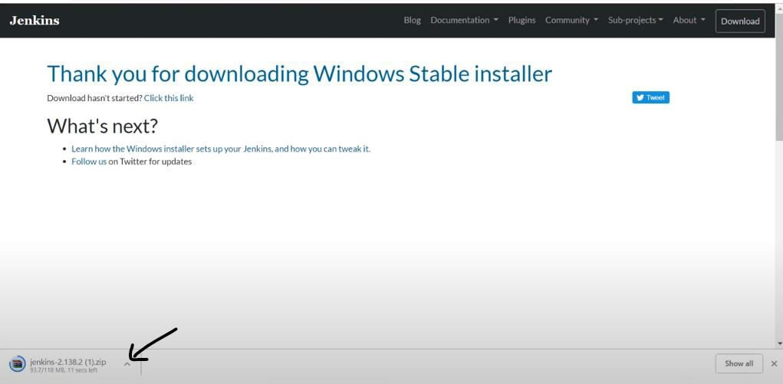

* Click on the folder and unzip it.

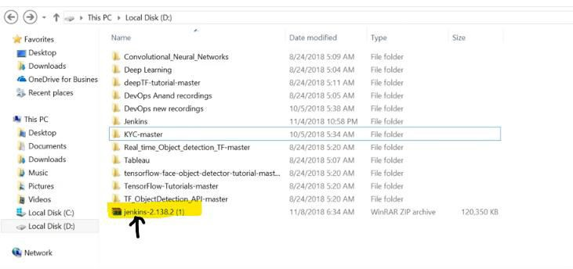

* Click on extract to, then select your path to install, click on OK.

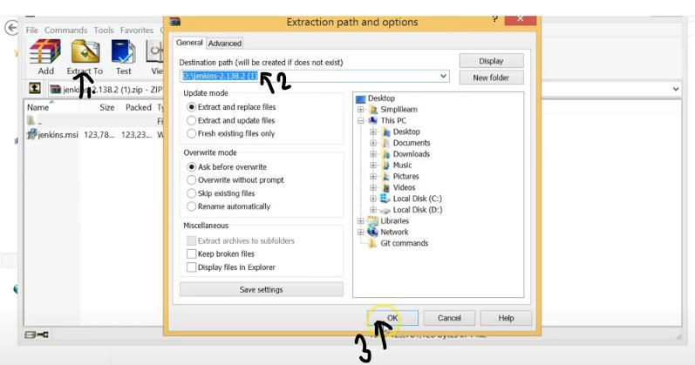

* Extracting from jenkins

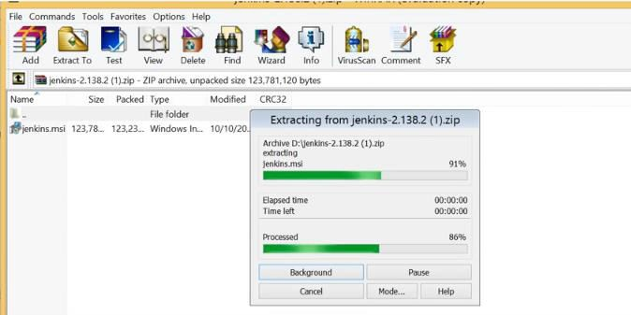

* Now you can see the Jenkins folder, Click on it.

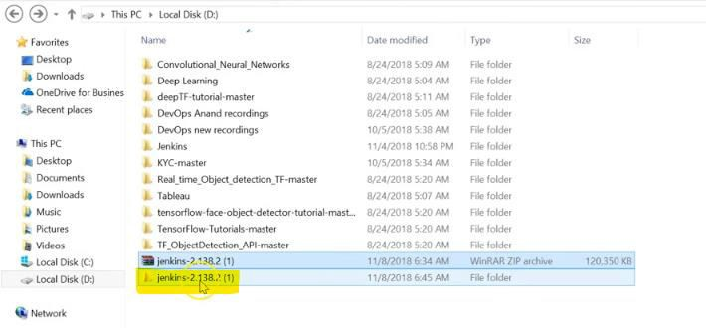

* Click on jenkins and select Run

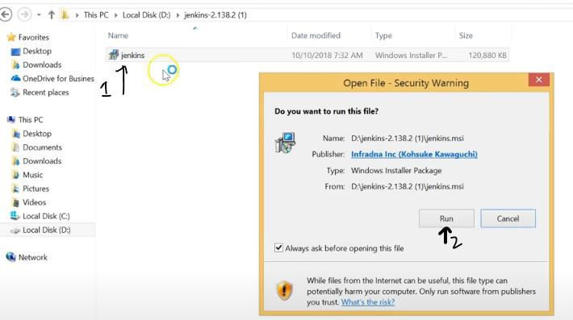

## Select Next

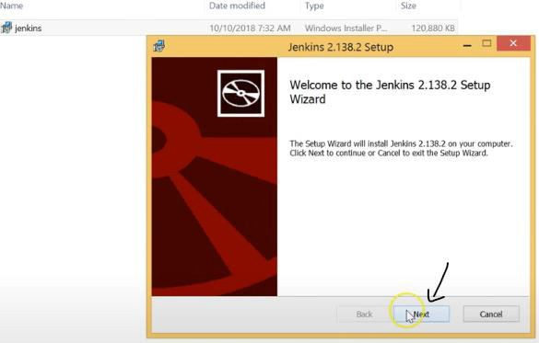

* Choose your path or keep it as a default and select next

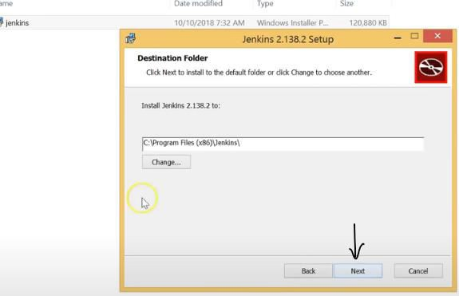

* Click on Install

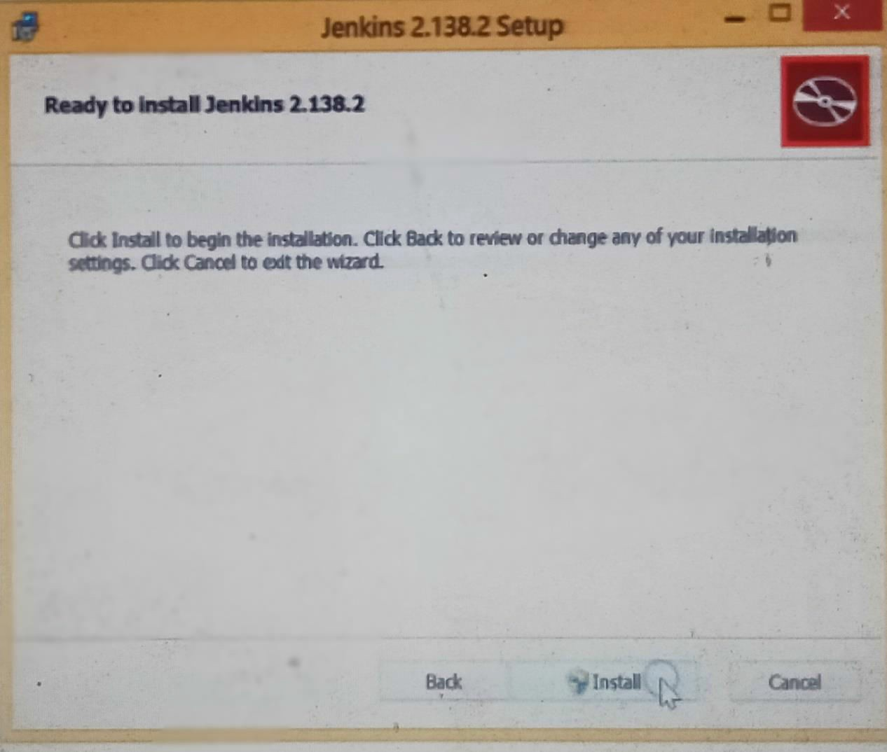

## Jenkins is installing

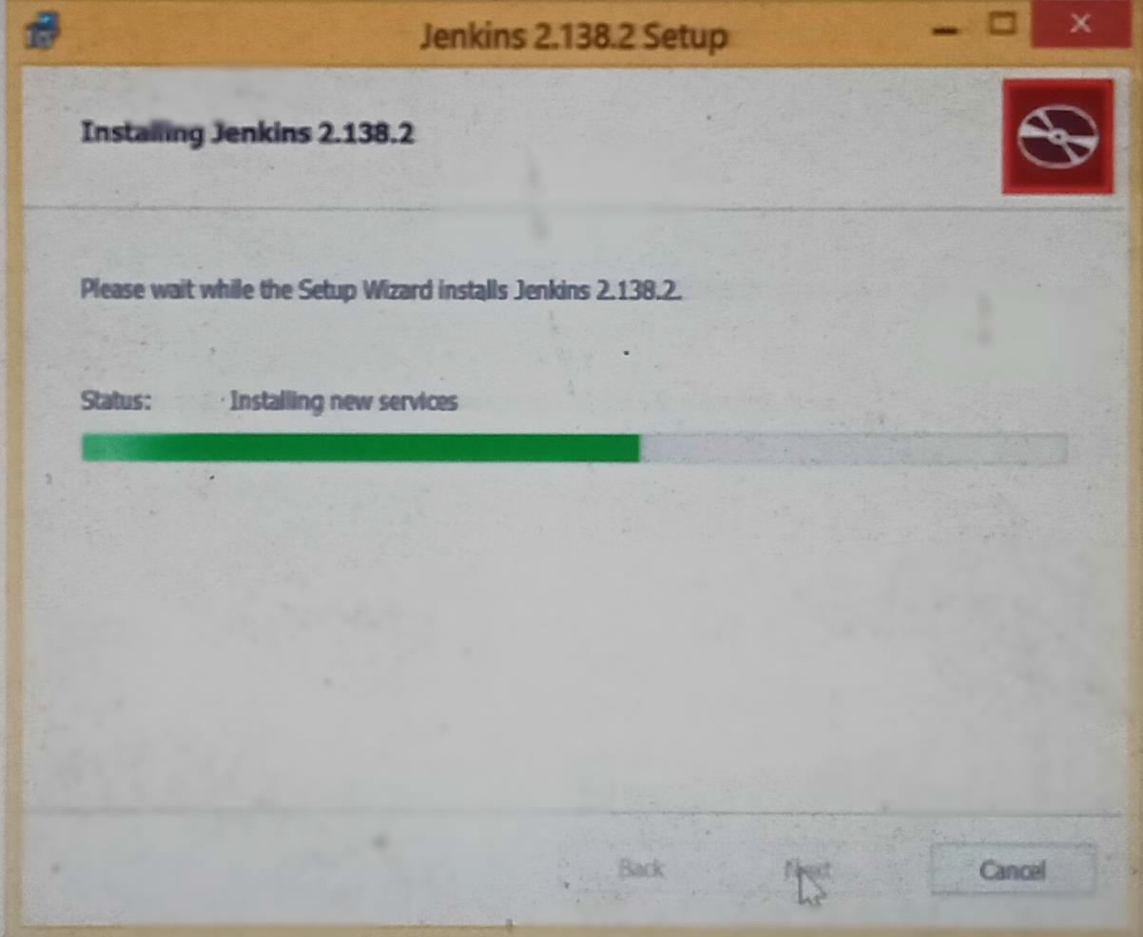

* Click on "finish" once done.

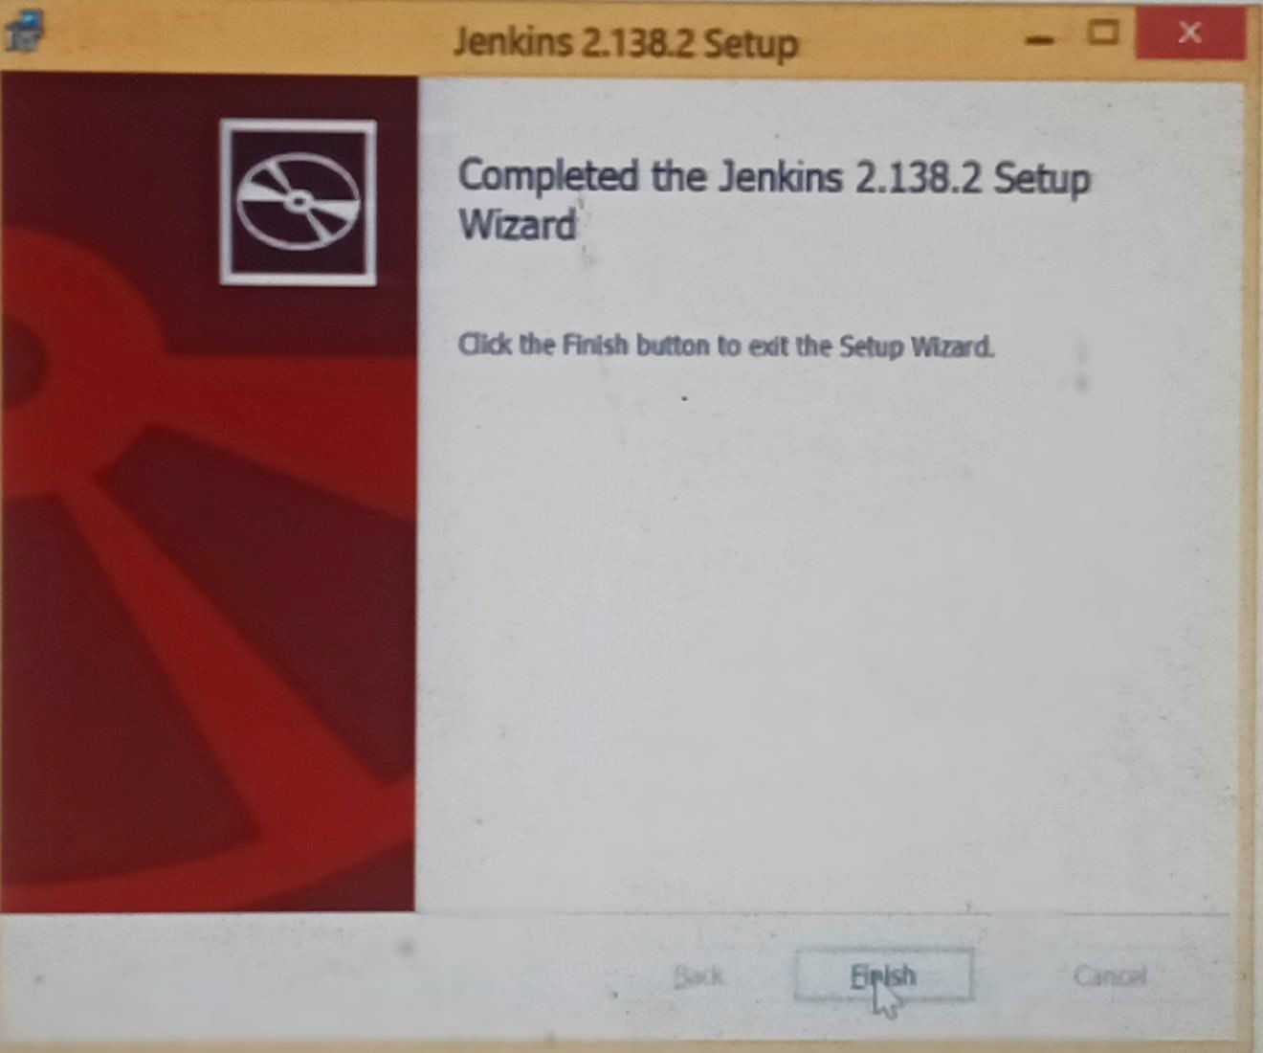

**4. Run Jenkins on Localhost 8080**

* Once Jenkins is installed, explore it. Open the web browser and type

"localhost:8080".

* Enter the credentials and log in. If you install Jenkins for the first time, the dashboard will ask you to install the recommended plugins. Install all the recommended plugins.

**5. Jenkins Server Interface**

* New Item allows you to create a new project.
* Build History shows the status of your builds.
* Manage System deals with the various configurations of the system.

1. **Build and Run a Job on Jenkins**

* Select a new item (Name - Jenkins_demo). Choose a freestyle project and click

Ok.

* Under the General tab, give a description like "This is my first Jenkins job." Under the "Build Triggers" tab, select add built step and then click on the "Execute Windows" batch command.
* In the command box, type the following: echo "Hello... This is my first Jenkins

Demo: %date%: %time% ". Click on apply and then save.

* Select build now. You can see a building history has been created. Click on that. In the console output, you can see the output of the first Jenkins job with time and date.
* Congratulations, you've just installed Jenkins on your Windows system!